# **Name: Abdurrahman Qureshi**

# **Roll No: 242466**

Practical No: 1

Date Of Performance: 07/07/2025

Aim: To encrypt and decrypt messages using different mono-alphabetic cipher techniques and frequency analysis

Ceaser Cipher:

CODE:

alphabets = "ABCDEFGHIJKLMNOPQRSTUVWXYZ "

def ceaser_cipher_encrypt(plain_text: str, key):

    if len(plain_text) == 0: return

    plain_text = plain_text.upper()

    plain_text = plain_text.strip()

    encrypted_message = ""

    characters_in_plain_text = []

    for i in plain_text:

        mapped_index = alphabets.index(i)

        encrypted_message = encrypted_message + alphabets[(mapped_index + key) % 27]

        if i not in characters_in_plain_text:

            characters_in_plain_text.append(i)

    print("Length of the plain text:", len(plain_text))

    for i in characters_in_plain_text:

        if i == " ":

            print(f"Frequency of ' ' in plain text is {(len(plain_text) / plain_text.count(i))}%")

        else:

            print(f"Frequency of {i} in plain text is {(len(plain_text) / plain_text.count(i))}%")

    print(characters_in_plain_text)

    return encrypted_message

def ceaser_cipher_decrypt(cipher_text: str, key):

    if len(cipher_text) == 0: return

    decrypted_message = ""

    cipher_text = cipher_text.upper()

    cipher_text = cipher_text.strip()

    for i in cipher_text:

        mapped_index = alphabets.index(i)

        decrypted_message = decrypted_message + alphabets[(mapped_index - key) % 27]

    return decrypted_message

original_message = "Death is an old friend"

print("Original Message: ", original_message)

encrypted_message = ceaser_cipher_encrypt(original_message, 3)

print("Encrypted Message: ", encrypted_message)

decrypted_message = ceaser_cipher_decrypt(encrypted_message, 3)

print("Decrypted Message: ", decrypted_message)

OUTPUT:

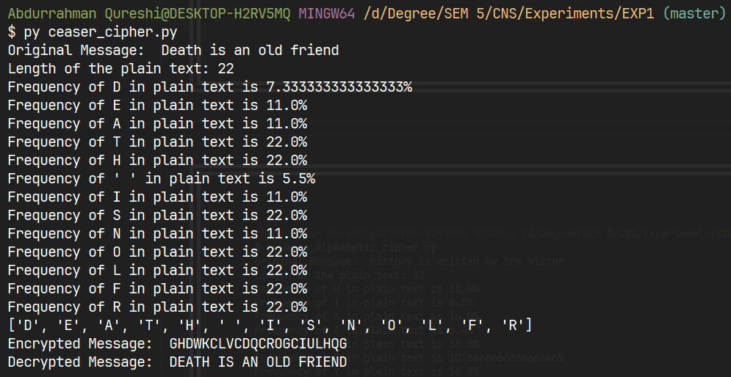

Mono-Alphabetic Cipher:

CODE:

alphabets = "ABCDEFGHIJKLMNOPQRSTUVWXYZ "

substituted_alphabets = "PJBTDGQRVHXCKLZOMFYWNAIUSE/"

def mono_alphabetic_encrypt(plain_text: str):

    if len(plain_text) == 0: return

    plain_text = plain_text.upper()

    plain_text = plain_text.strip()

    encrypted_text = ""

    characters_in_plain_text = []

    for i in plain_text:

        mapped_index = alphabets.index(i)

        encrypted_text = encrypted_text + substituted_alphabets[mapped_index]

        if i not in characters_in_plain_text:

            characters_in_plain_text.append(i)

    print("Length of the plain text:", len(plain_text))

    for i in characters_in_plain_text:

        if i == " ":

            print(f"Frequency of ' ' in plain text is {(len(plain_text) / plain_text.count(i))}%")

        else:

            print(f"Frequency of {i} in plain text is {(len(plain_text) / plain_text.count(i))}%")

    print(characters_in_plain_text)

    return encrypted_text

def mono_alphabetic_decrypt(cipher_text: str):

    if len(cipher_text) == 0: return

    cipher_text = cipher_text.upper()

    cipher_text = cipher_text.strip()

    decrypted_text = ""

    for i in cipher_text:

        mapped_index = substituted_alphabets.index(i)

        decrypted_text = decrypted_text + alphabets[mapped_index]

    return decrypted_text

original_message = "History is written by the victor"

print("Original Message: ", original_message)

encrypted_message = mono_alphabetic_encrypt(original_message)

print("Encrypted Message: ", encrypted_message)

decrypted_message = mono_alphabetic_decrypt(encrypted_message)

print("Decrypted Message: ", decrypted_message)

OUTPUT:

